CRM7 System Walkthrough Pt 4 Minutes
4.14.2026 |  | 10:45AM – 12:15PM EST
Team | Customer
Facilitators | Jose, Dawn, Tara
Note taker | Taylor
Attendees | Jose, Dawn, Tara, Taylor
Notes:
ORDER MANAGEMENT*
- Create and order and view in ECC
- Want the CSR to complete Service Order during Move in

Pre move in screen
Information auto populates
If Active account – prefills address
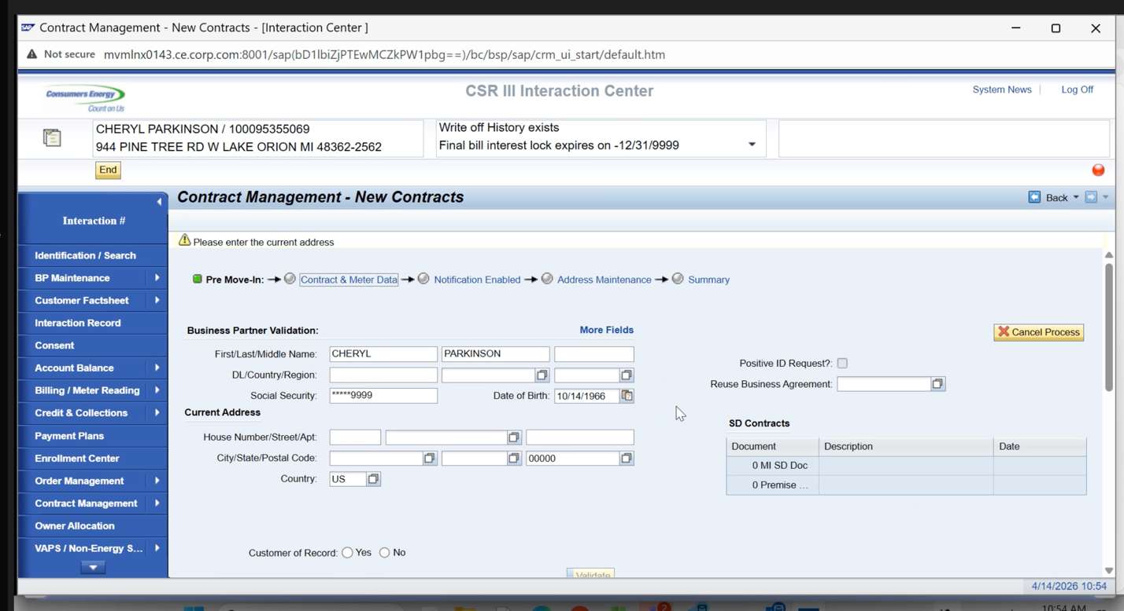
SD Contracts = (Exposed custom table in front end) ASP – Not relevant for future state

Need to use specific data from Equifacts

Customer of Record (is the person calling the customer of record vs. if it’s a spouse)
Used to be able to have a land lord do a move in, that no longer is allowed

If not the customer of record cannot proceed with the move in and cancel.
CSR agent wouldn’t start move in since they can see the name on the left of the screen

“Validate” Validates identity Triggers Equifacts
CSRs can’t skip validation
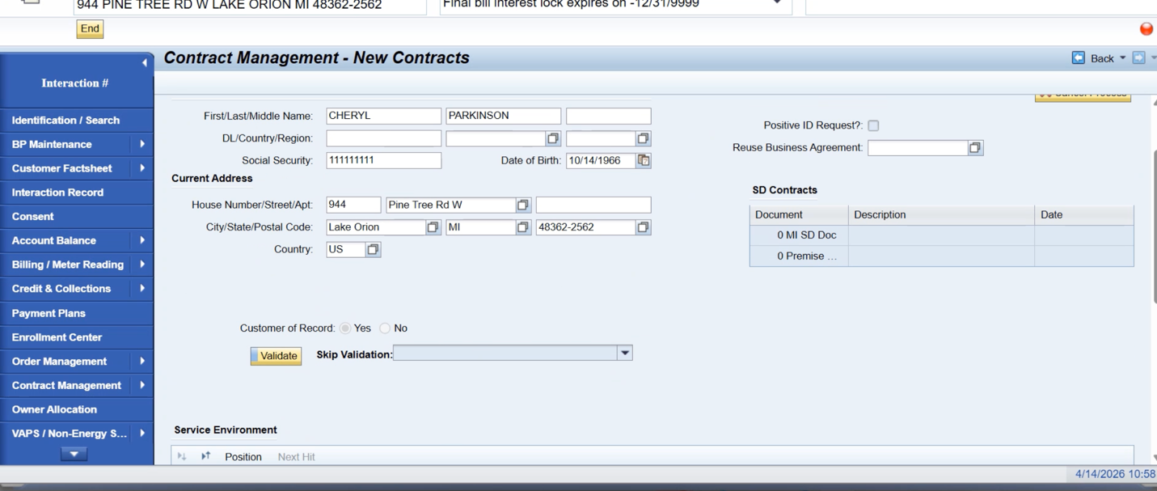

FACTA Validation is Required

Positive ID Request Frad uses
- Requirement before move in is active
- PIR Email sent (DAWN put PIR doc in CRM documentation folder)

Originally the Social Security Autopopulated and was masked when we got to this screen

Defaulted to not reuse business agreement. When new gas service was added it wouldn’t put it on the same account as the electric

This only works well if Electric was on it and nothing fancy about It and gas is added or vice versa

If Existing Gas and Electric Two contracts under 1 account

New Premise – never use the old account number

Need the option in some scenarios to Reuse Business Agreement

If FACTA Validation Fails then it will read “Notification Disabled”

CONTRACT AND METER DATA
Contract and Meter Data Custom Screen

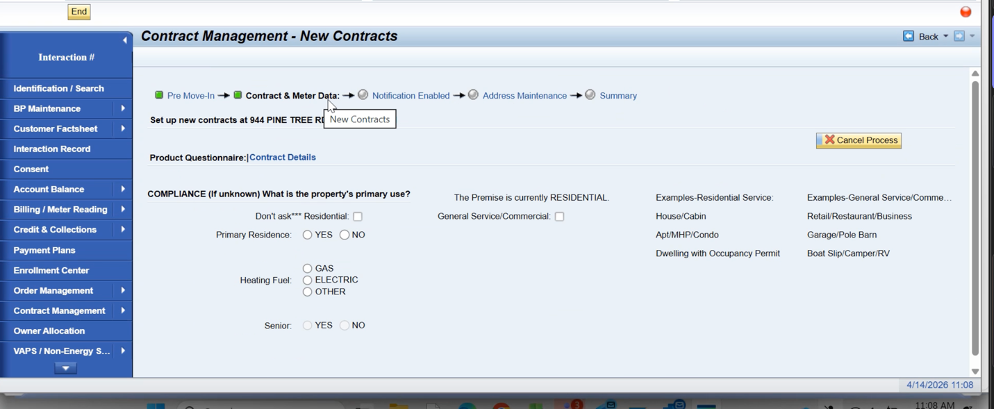
Premise is determined as residential vs. commercial depending on the rate

Are these fields being saved somewhere – no? This drives operands for where they get their Senior credit. Never have stored this information in a table. No good logical place of what table to put it in.

Future State = Primary Residence will have to stay in order to get their senior credit
New Pop up will ask again to verify Primary

Enrollment Center for Products no temporary paperwork, just enroll
Same for Payment Plans no temporary paperwork, just enroll

Automatically get from State Agencies (20+) only 1 does that type of credit
Will have to Regression test

General Service/ Commercial box Changes the rate category
Rate Defaults to Commercial rate
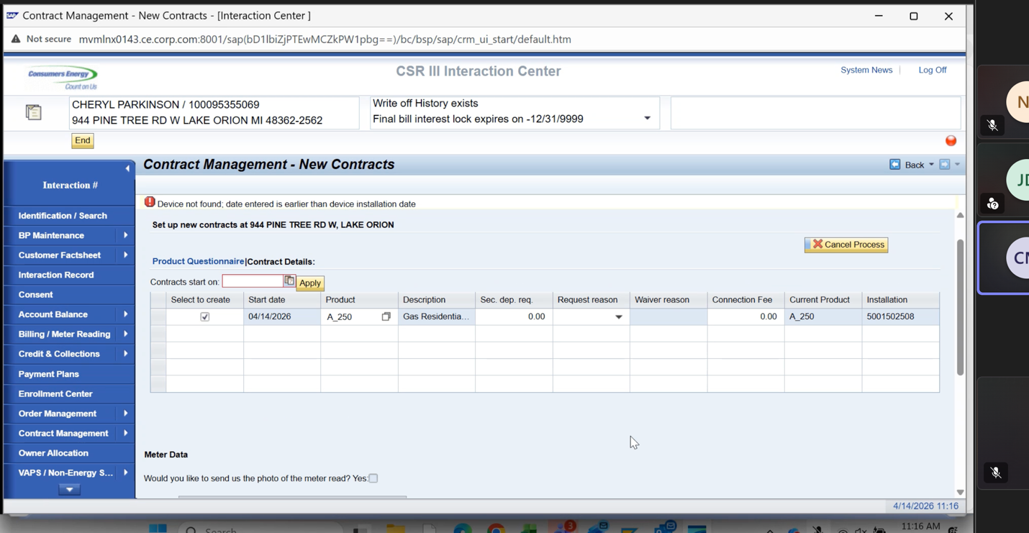
Originally was a residential rate A_25
Commercial select automatically adjusts to a commercial rate

Residential customer can be getting commercial bill if selected improperly
Move ins on incorrect rates
Pain Point (Brought up during service cloud discussions)

Muscle problem with selecting Residential

Do have to give option to alter rates
Future State: Commercial account / commercial premise – a pop up or something to validate Residential vs Commercial

Going from Residential to commercial for builders
- When a move in is done, if the rate wasn’t changed properly, they need to change to a residential rate

Different Rate options presented for Electric Move in

TOPIC FOR EXPLORE: Need a decision from the Business on Cleaning up Contract Management – New Contracts
The rate that is defaulting, is the most standard default rate

Security Deposits – for Both Residential and Commercial customers
Pretty much standard fee populated
65 – gas
95- electric
Comb0 $160, breaks down into rows

Commercial $$$s document breakdown should already be CRM7 Sharepoint

- Ajay and CK Integrations for Thursday’s call
- Lead for Digital – Tanya (nothing is changing for Digital)

Case management will be a strong RIDA

eBill Flag – for Contract Account
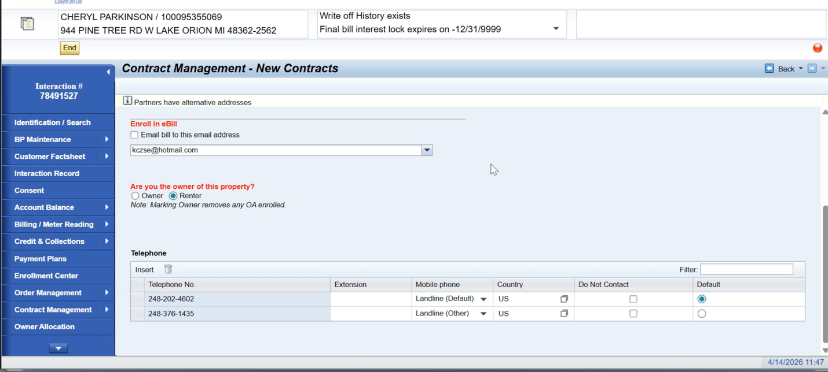
Once flagged – sent to Kubra

If Owner allocation on the premise – can remove

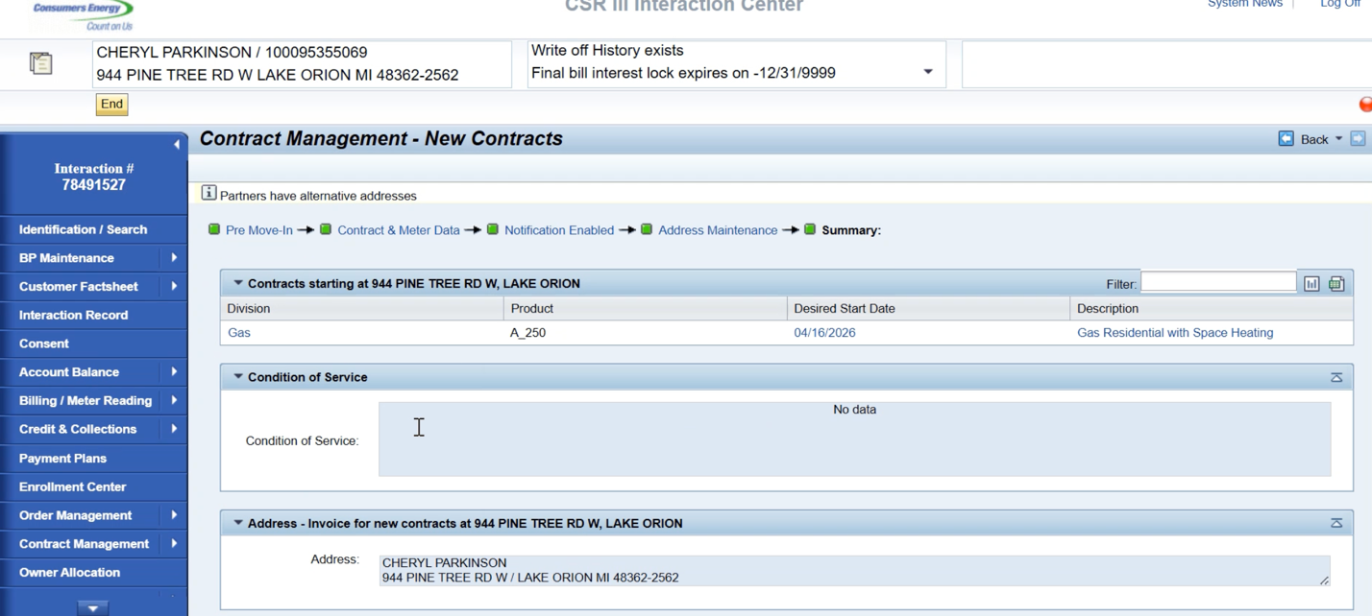
Review of order created

Condition of Service Custom Field
Actual Notification Information Custom Field

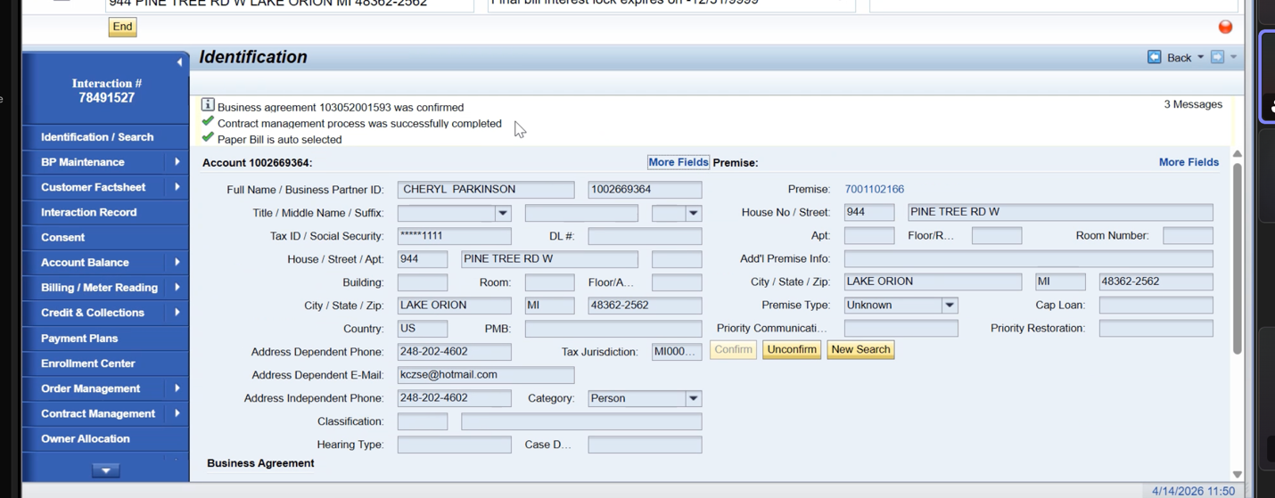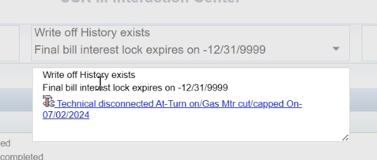

Any custom hard stops embedded in the Submit button?
Custom messages stopping you from performing move in
- System allowed you to advance without a mailing address

Hard Stops before leaving the Address Maintenance field

Order is now in Order Management ->
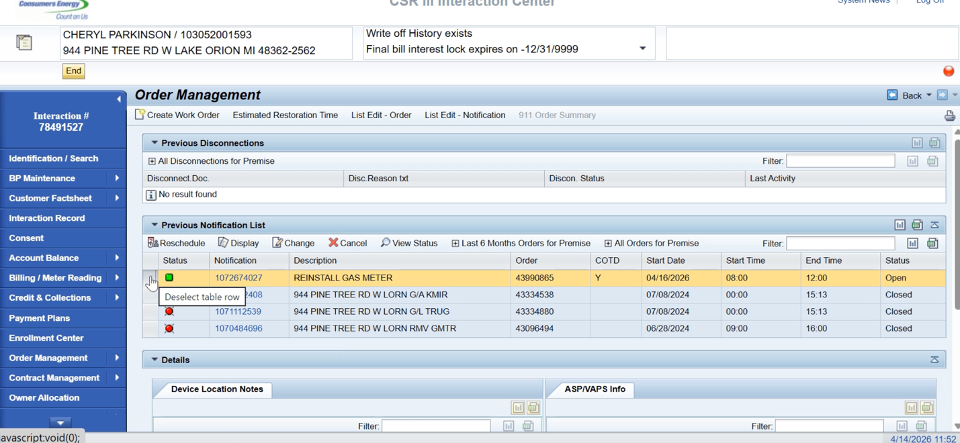
Can select by BP Premise or just premise

Interaction # is generated after hitting submit
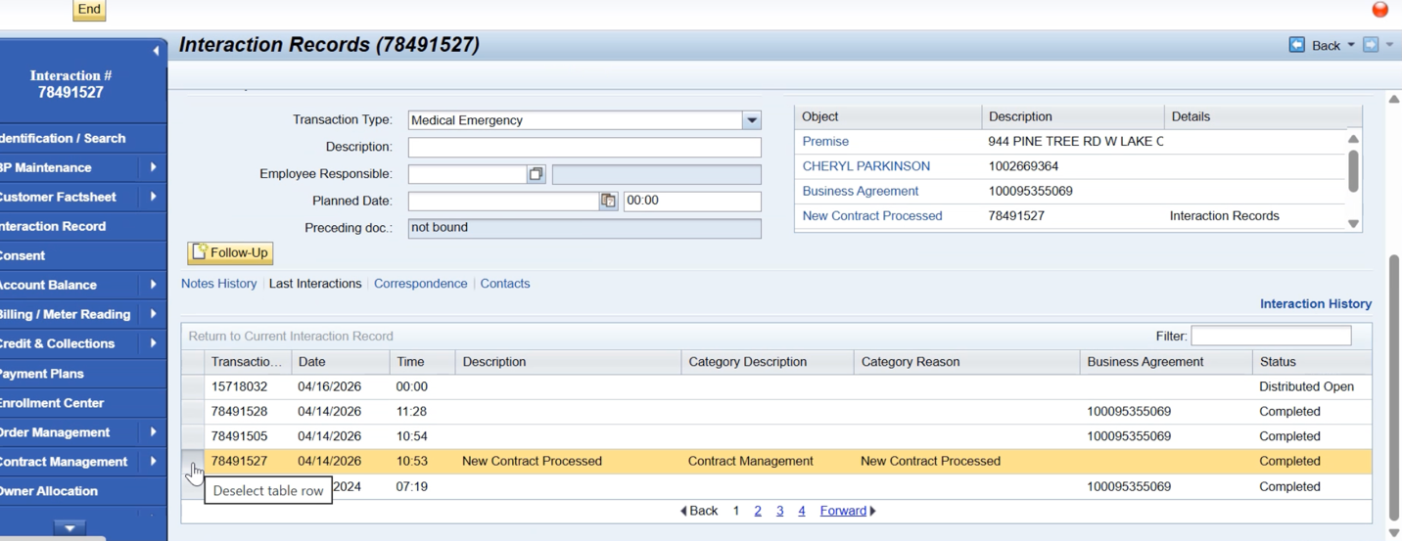

CHANGE CONTRACTS
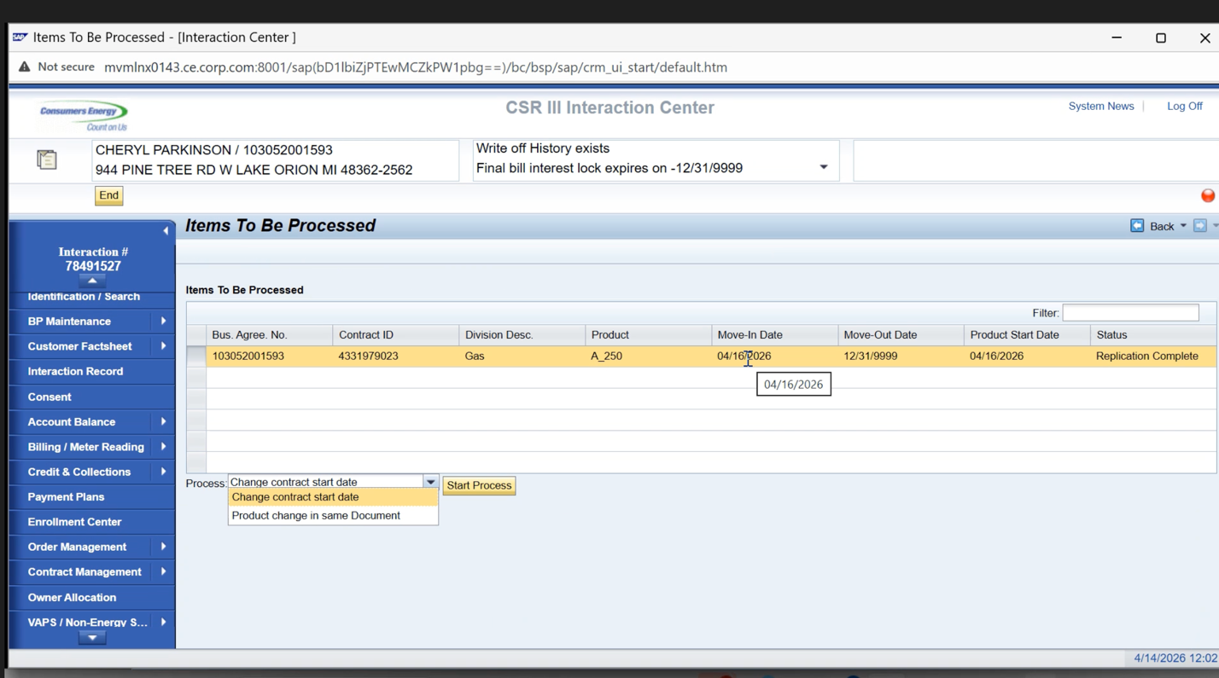

- Can change rate starting 1 day after the move in date
- If you do a rate change – it wont bill and a case is created for unbilled revenue
- Would go in and reverse the move in in order to change back to the state
- Can change the product the day of the product change
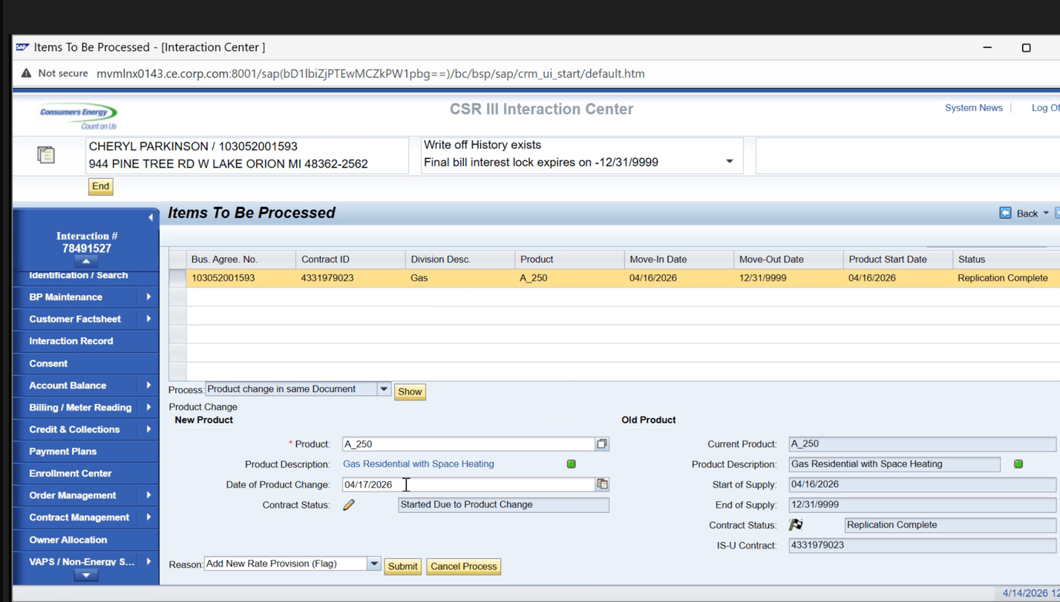

For Move in Reversal, you can select both lines for multipe contracts

No check for supplier in current state, when they want to enroll
They enroll with Supplier directly
CSR will change to GCC Rates
any cancellations done to the switch documents

END Contract Move out
Meter data decision

Redwood – batch jobs scheduled through here
No other address validation systems other than DQM
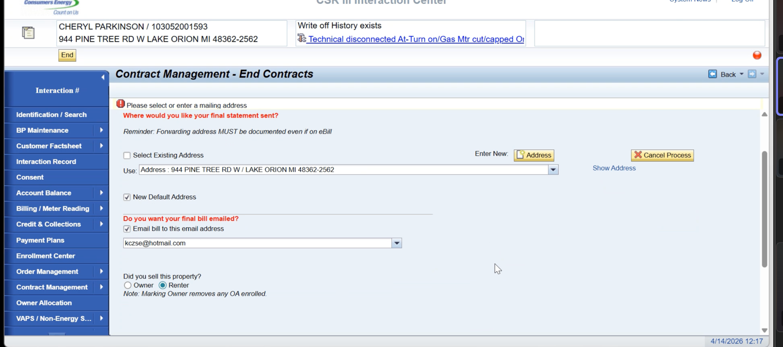

Translate this into an alert or a message up top

If they are on Paper bills, they get a supplemental ebill
Because its supplemental, they are still able to receive ebills since they are receiving paper
(this was a decision from the digital team)

Marketing team does not use SAP

Owner Allocation
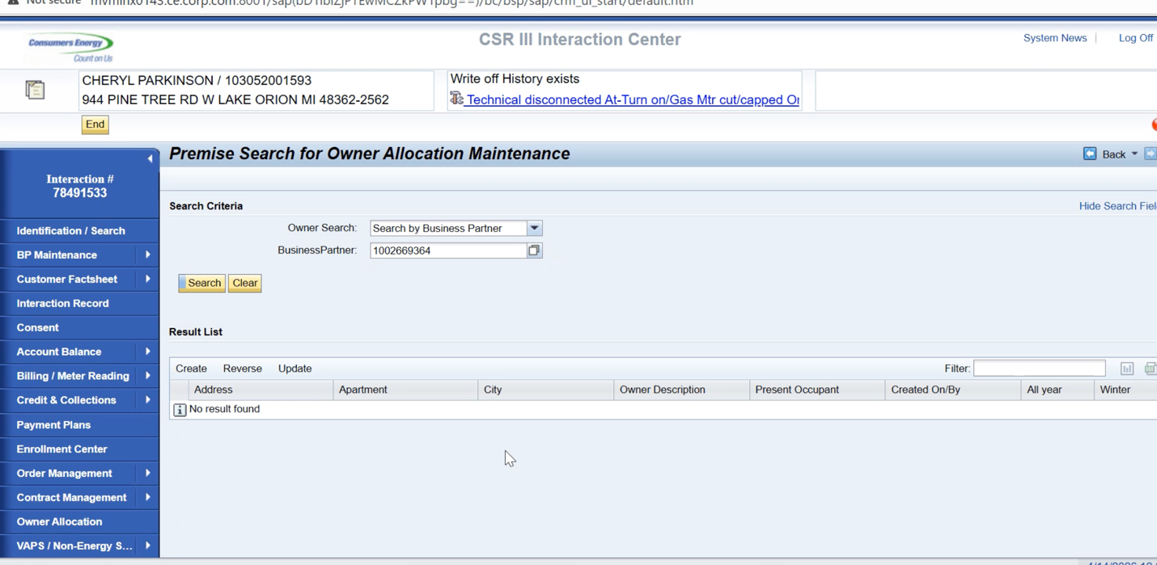
Create, Reverse, Update,

Table create

All year vs winter allocation
Winter Nov 1- Mar 31st
Owner can chose that to avoid turnoffs

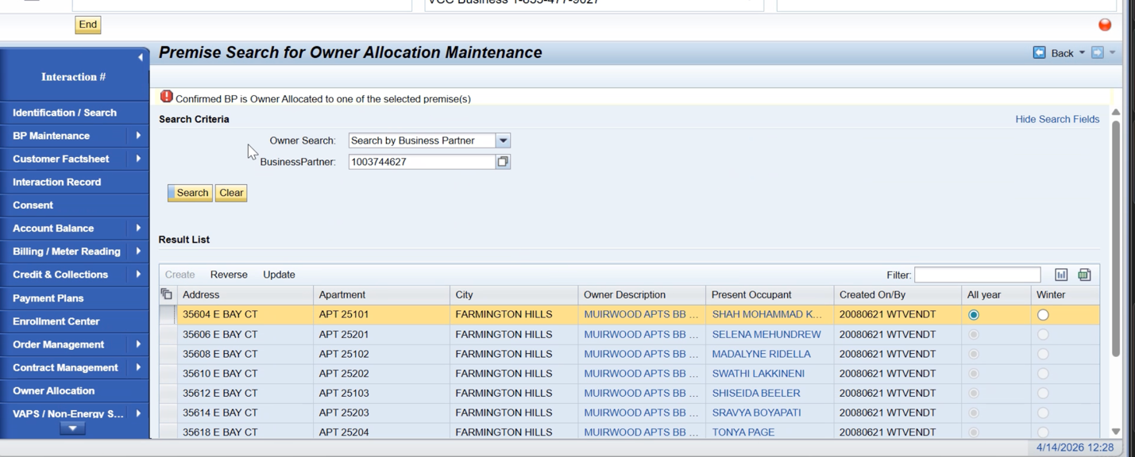
How do we know the owner of the apt building, make themselves known when calling in

Landlord Portal – don’t assign the owner allocation themselves, the landlord team does that. The actual designation starts here in CSR. Need to be enrolled in Owner allocation to access that portal

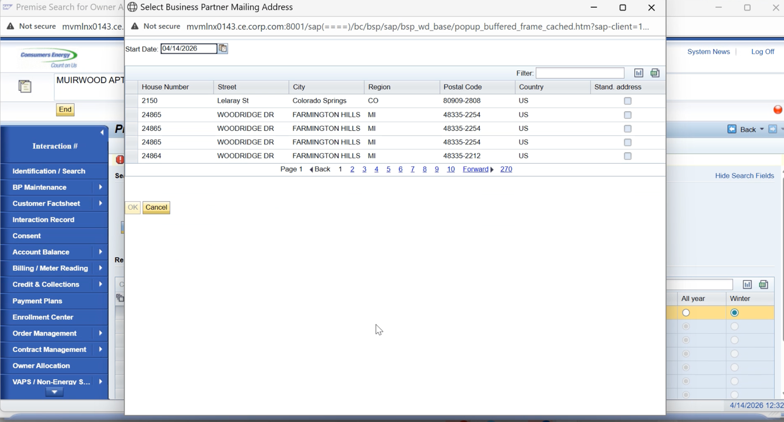
Change address for Owner Allocation
Business Master Data

So many unused mailing address since many of the tenants were given the mailing address of the owners.

P/F = Pass / Fail

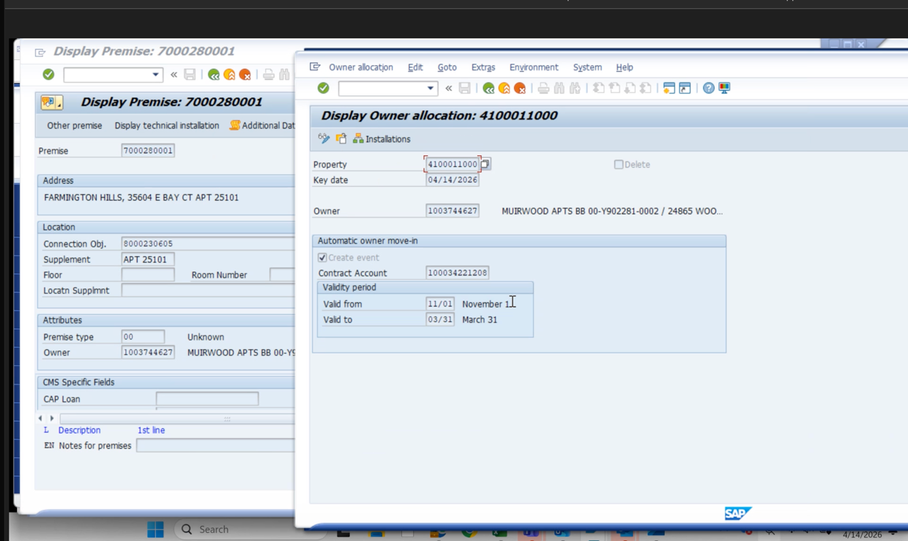

Yes, can add in owner allocation would create the flag and property automatically

Dawn things they should make everyone do Owner allocation year round

Leave alive for a certain period of time. Risk on the err of caution and leave on. It’ll go onto the current occupant workflow.

ONLINE ACCOUNT TRANSFER Z FIELD FROM LAST WEEK’S DISCUSSION

Key Decisions
Do have to give option to alter rates
Future State: Commercial account / commercial premise – a pop up or something to validate Residential vs Commercial

TOPIC FOR EXPLORE: Need a decision from the Business on Cleaning up Contract Management – New Contracts
Action Items |  |  |  | Person Responsible | Tracking?
Dawn will get State Agency Detail she sent to Som and JJ |  |  |  | Dawn | ADO Task in Pre-Work for CRM7
Need to decide on RIDAs for Service Cloud Need to wait until Service Cloud V2 Demo has been done in order to have a constructive conversation |  |  |  | Taylor Create action item in ADO to Schedule SCV2 RIDA Discussion | Excel sheet in SP Service Cloud V2 Folder to start tracking RIDAS for V2
Commercial $$$ Breakdown Doc in Sharepoint |  |  |  | Taylor find in Sharepoint | ADO Task in Pre-Work for CRM7
All coming from ECC and into CRM  Direct Integrations from CRM to a 3rd Party // flowing through ECC  No Direct from CRM to any system, all are VIA ECC ECC This will be a RIDA in further Service Cloud Discussions |  |  |  | Taylor add to Excel Tracker of V2 RIDAs (Not putting in ADO yet since we need to meet to decide on the official RIDAs) | Excel sheet in SP Service Cloud V2 Folder to start tracking RIDAS for V2
Service Order vs. Notifications Decisions will need to happen with WAM team This will be a RIDA in further Service Cloud Discussions |  |  |  | Dawn, Jose | Excel sheet in SP Service Cloud V2 Folder to start tracking RIDAS for V2
Do we actually want to Add and close RIDA for Removing Meter data ??? Make this part of the V2 RIDA list? |  |  |  | Taylor quickly connect with Dawn | Excel sheet in SP Service Cloud V2 Folder to start tracking RIDAS for V2
Remove move in move out workflows once Jose get’s access (Workflow document ) |  |  |  | Jose | ADO Task in Pre-Work for CRM7

